Spcm lab 13

Khushi chauhan

Batch B1 H

Objective: To work with hosts both individually and in groups for streamlined management and deployment across your network infrastructure Tools required: Ubuntu OS Prerequisites: You need to have Ansible, and the nodes connected with it installed to proceed with this demo. Refer Demo 1 of Lesson 3.

Steps to be followed: 1. List the hosts present in your host file 2. Create a file on the host 3. Remove the file from the host 4. Create and remove the file on the hosts using the group 5. Update the hosts using the group

Step 1: List the hosts present in your host file

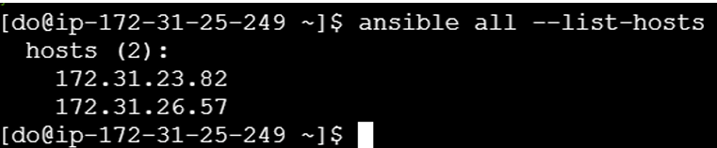

Step 2: Create a file on the host

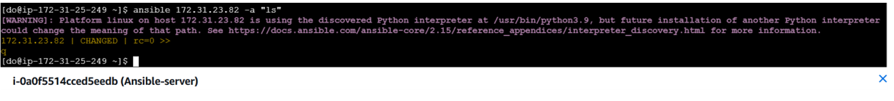

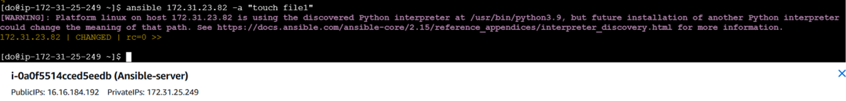

Step 3: Remove the file from the host

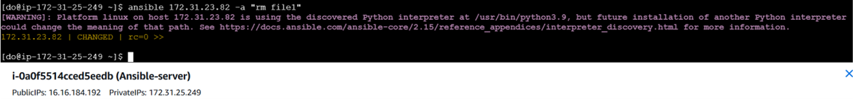

Step 4: Create and remove the file on the hosts using the group

